*1. Check Positive Number:*

*Task: Create a flowchart to check whether a number is positive.*

*Next Step: Write a Java program that checks if a predefined number is positive using an*

*if-else statement and prints the appropriate message.*

**

*import java.util.Scanner;*

*class Check{*

*public static void main (String args[]){*

*int n;*

*Scanner sc = new Scanner(System.in);*

*System.out.println(" Please enter the number");*

*n = sc.nextInt();*

*if(n>0){*

*System.out.println(n + " is a Positive number");*

*}else{*

*System.out.println(n + " is not a Positive number");*

*}*

*}*

*}*

*Check Negative Number:*

*• Task: Create a flowchart to check whether a number is negative.*

*• Next Step: Write a Java program that checks if a predefined number is negative using an*

*if-else statement and displays the result.*

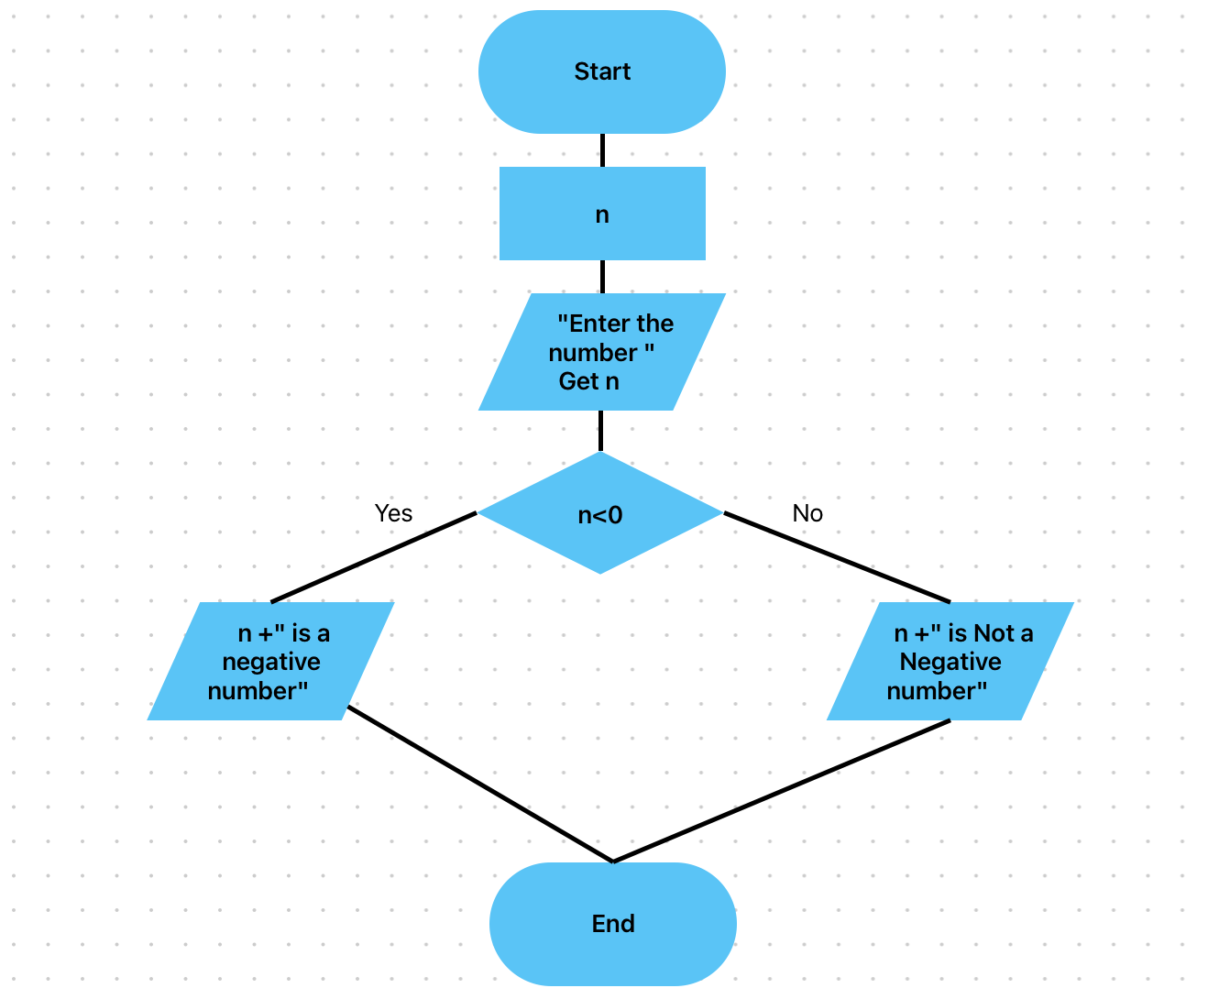

*import java.util.Scanner;*

*class Check{*

*public static void main (String args[]){*

*int n;*

*Scanner sc = new Scanner(System.in);*

*System.out.println(" Please enter the number");*

*n = sc.nextInt();*

*if(n<0){*

*System.out.println(n + " is a Negative number");*

*}else{*

*System.out.println(n + " is not a Negative number");*

*}*

*}*

*}*

*3. Check Odd or Even Number:*

*• Task: Create a flowchart to determine whether a number is odd or even.*

*• Next Step: Write a Java program that checks if a predefined number is odd or even. Use*

*an if-else statement and the modulus operator (%) to determine whether the number is*

*divisible by 2 or not.*

*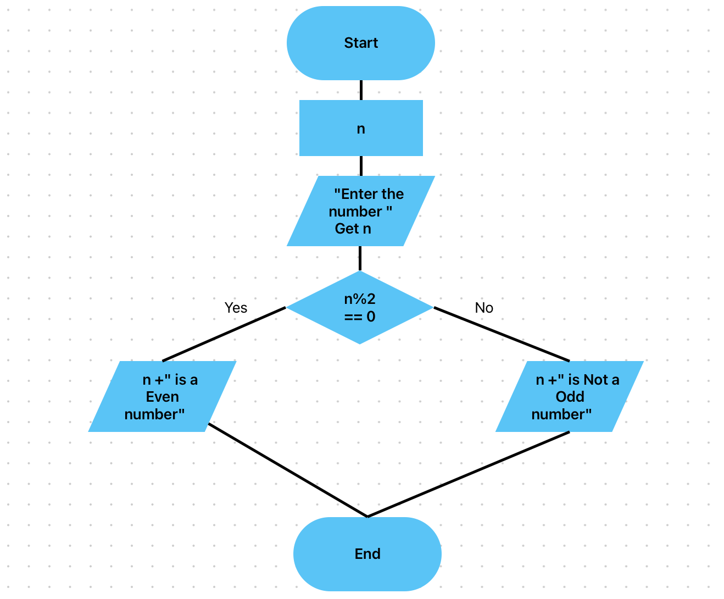*

import java.util.Scanner;

class Check{

public static void main (String args[]){

int n;

Scanner sc = new Scanner(System.in);

System.out.println(" Please enter the number");

n = sc.nextInt();

if(n%2 == 0){

System.out.println(n + " is a Even number");

}else{

System.out.println(n + " is a Odd number");

}

}

}

*4. Display Good Morning Message Based on Time:*

*• Task: Create a flowchart to display a "Good Morning" message based on a given time.*

*• Next Step: Write a Java program that displays a "Good Morning" message if the*

*predefined time is between 5 AM and 12 PM. Use an if statement to implement the logic.*

*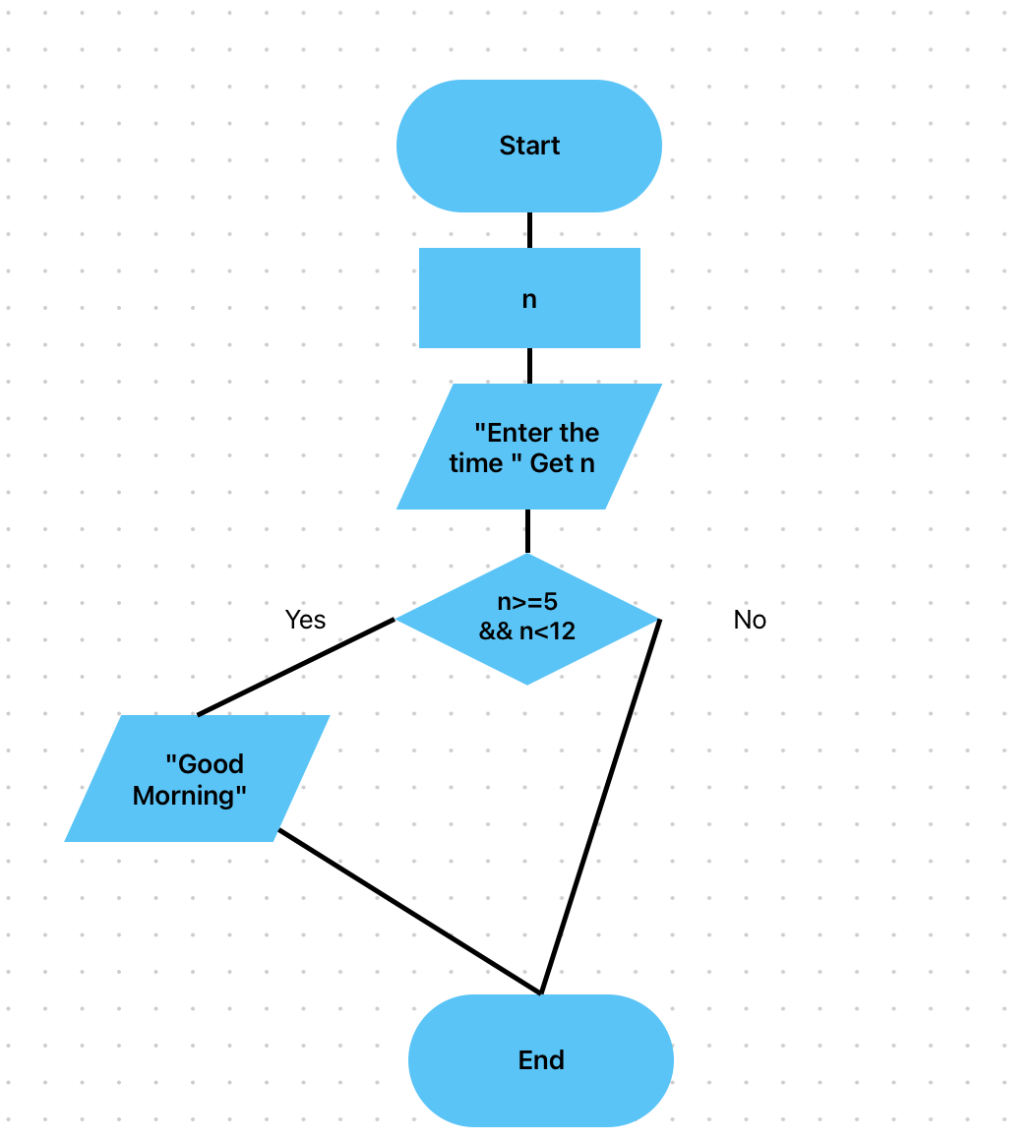*

*import java.util.Scanner;*

*class Greet{*

*public static void main (String args[]){*

*int a;*

*Scanner sc = new Scanner(System.in);*

*System.out.println(" Whats the time");*

*a = sc.nextInt();*

*//considering 24 hour format*

*if(a>=5 && a<12){*

*System.out.println("Good Morning");*

*}*

*}*

*}*

*5. Print Area of a Square:*

*• Task: Create a flowchart to calculate and print the area of a square.*

*• Next Step: Write a Java program that calculates the area of a square using the formula*

*area = side \* side. Use a predefined side length.*

**

*import java.util.Scanner;*

*class Calculate{*

*public static void main (String args[]){*

*int n;*

*Scanner sc = new Scanner(System.in);*

*System.out.println(" Please Length of Side in meter");*

*n = sc.nextInt();*

*int area = n\*n;*

*System.out.println("Area of the Square is "+area+" SqM");*

*}*

*}*

*6. Print Area of a Rectangle:*

*• Task: Create a flowchart to calculate and print the area of a rectangle.*

*• Next Step: Write a Java program that calculates the area of a rectangle using the formula*

*area = length \* width. Use predefined values for length and width.*

*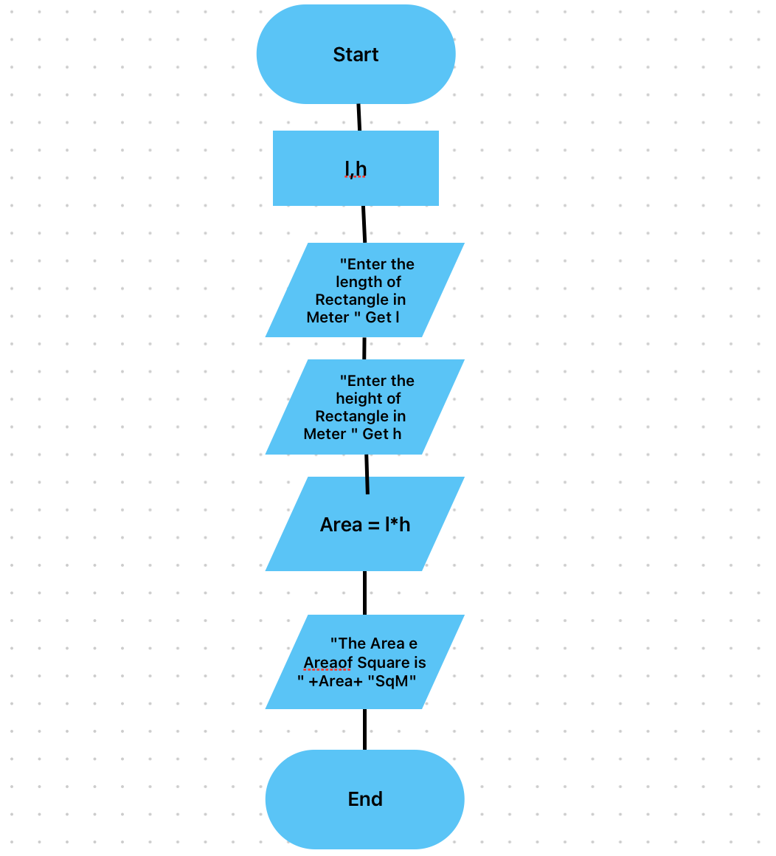*

*class Calculate{*

*public static void main (String args[]){*

*int l,h;*

*Scanner sc = new Scanner(System.in);*

*System.out.println(" Please Enter Length of Rectangle in meter");*

*l = sc.nextInt();*

*System.out.println(" Please Enter Height of Rectangle in meter");*

*h = sc.nextInt();*

*int area = l\*h;*

*System.out.println("Area of the Rectangle is "+area+" SqM");*

*}*

*}*

*7. Find the Largest of Three Numbers:*

*• Task: Create a flowchart to find the largest of three numbers.*

*• Next Step: Write a Java program that finds and prints the largest of three predefined*

*numbers using if-else statements.*

*import java.util.Scanner;*

*class Find{*

*public static void main (String args[]){*

*int a,b,c;*

*Scanner sc = new Scanner(System.in);*

*System.out.println(" Please Enter 3 numbers separately");*

*a = sc.nextInt();*

*b = sc.nextInt();*

*c = sc.nextInt();*

*int temp = a;*

*if(temp<b){*

*temp = b;*

*}*

*if(temp<c){*

*temp=c;*

*}*

*System.out.println("Largest no out of three numbers is " + temp);*

*}*

*}*